

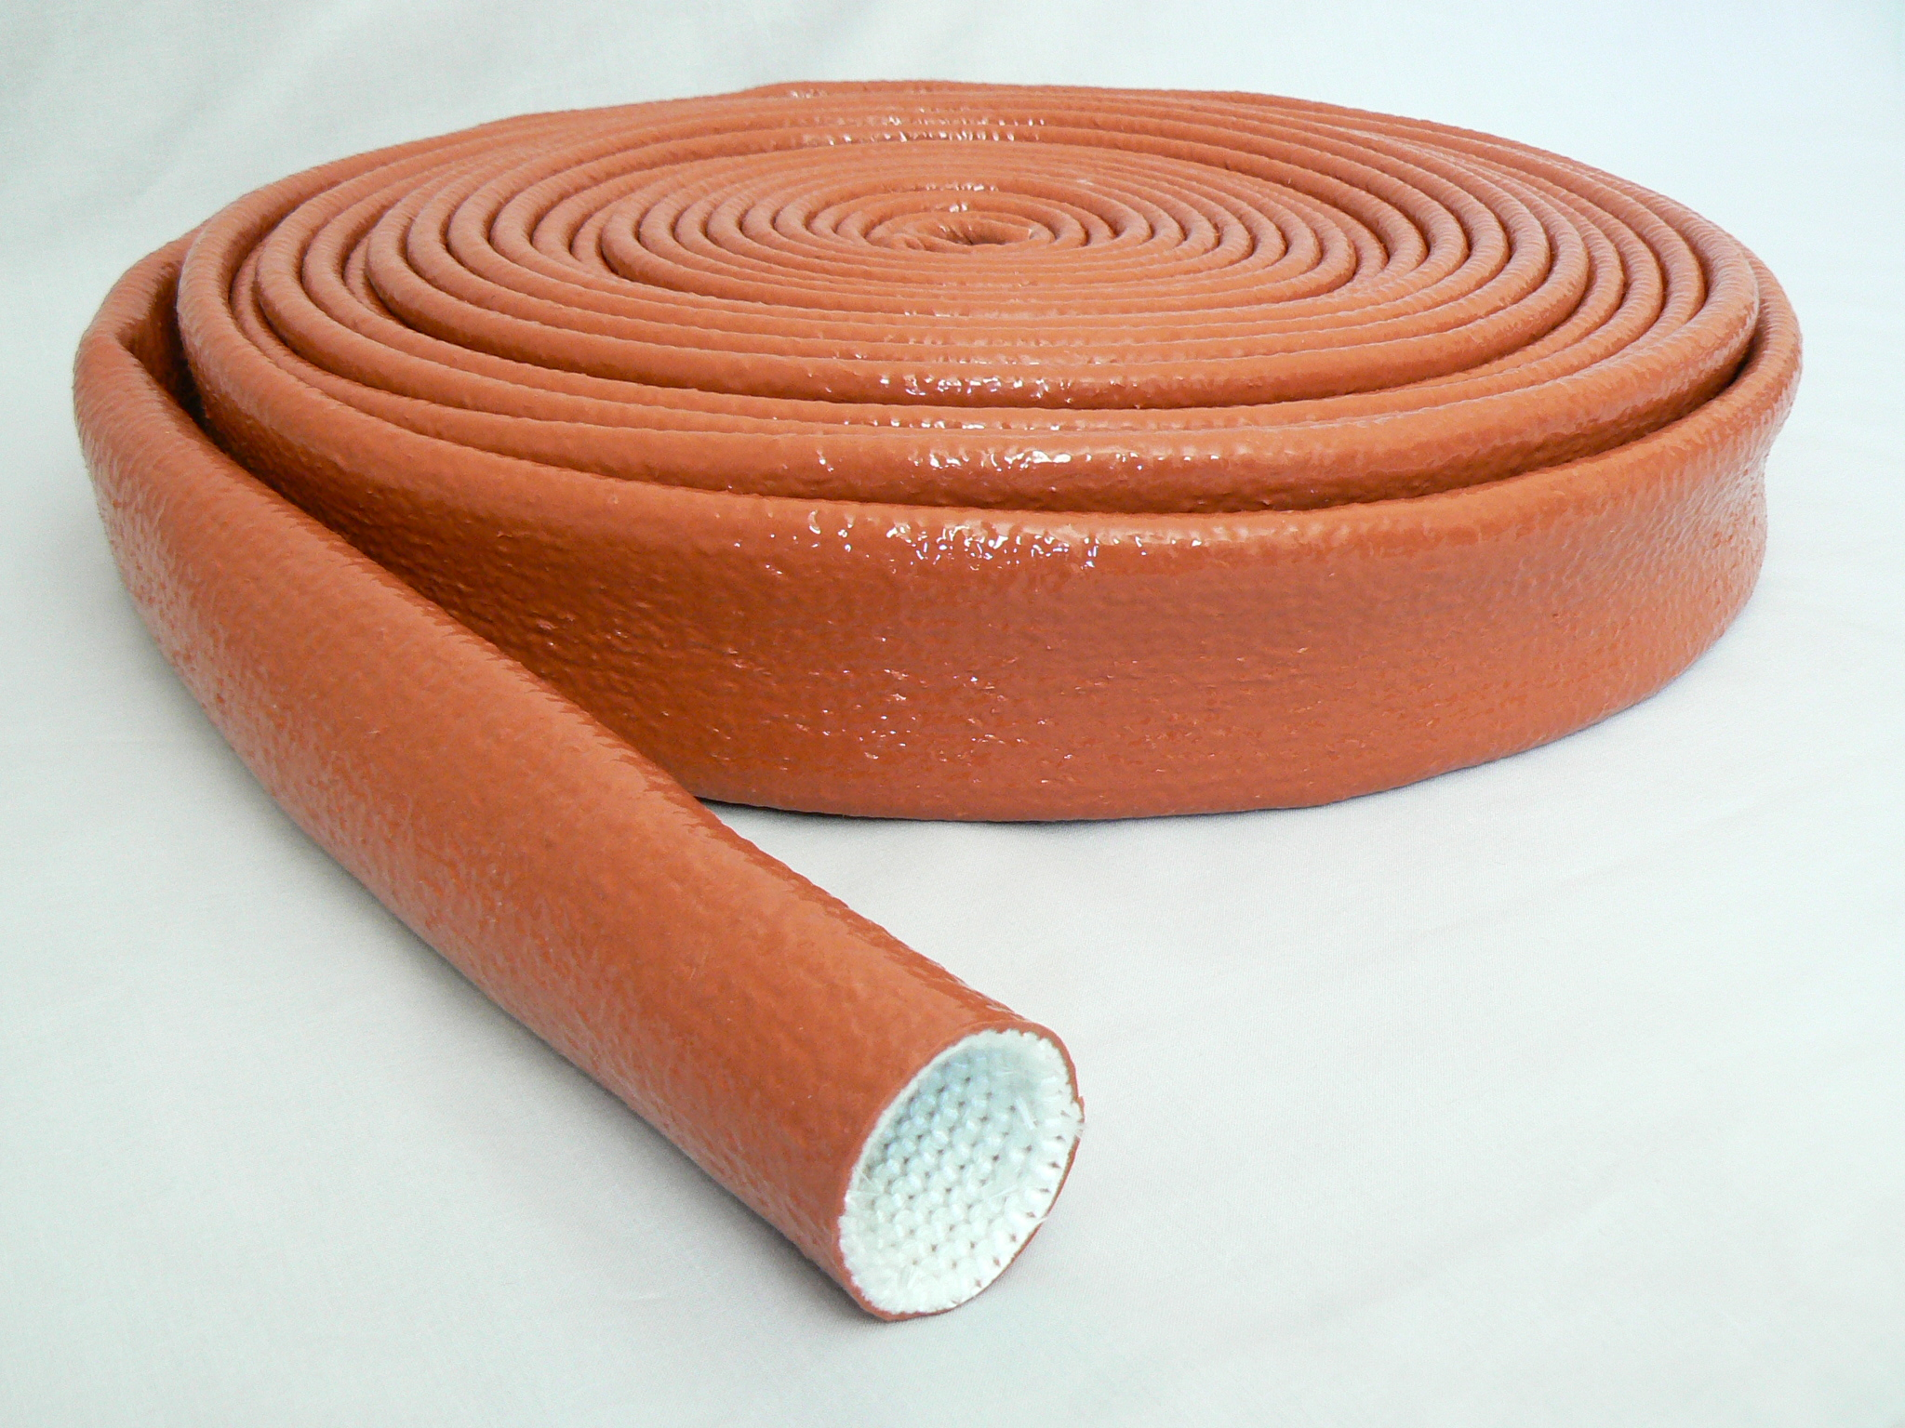

PYROSLEEVE PGH.20/ROS
Red Oxide Silicone Coated Glass Fibre Sleeving

PYROSLEEVE PGH.20/ROS is manufactured from ‘E’ glass fibre yarn knitted to form a sleeve and coated with high grade iron oxide silicone elastomer rubber.

PGH.20/ROS possesses outstanding characteristics making it ideal for protecting hose assemblies, cables, and wires.

- High flexibility
- Continuous protection at an operating temperature of 250 deg. C
- Ability to withstand a molten metal splash at 1200 deg. C
- Highly resistant to most oils, hydraulic fluids, fuels, acids and alkalis
- When exposed to flame the high grade rubber will form a protective SiO2 layer
- Health & Safety - Provides personnel with protection against burns from hot hoses, steam lines etc.
- Helps to reduce energy loss by retaining heat within pipework
- Excellent flame resistance
- Excellent abrasion resistance

PYROSLEEVE PGH.20/ROS
Red Oxide Silicone Coated Glass Fibre Sleeving

Available sizes Characteristics

Nominal inside diameters
(mm)
10 | Effect of heat | Will not burn.  Retains 75% tensile  @ 340°C
12 |  | Will not burn.  Retains 75% tensile  @ 340°C
16 |  | Will not burn.  Retains 75% tensile  @ 340°C
20
22 | Effects of acids & alkalis | Resistant to acids  is fair. Resistance to  Alkalis is good
25 |  | Resistant to acids  is fair. Resistance to  Alkalis is good
28 |  | Resistant to acids  is fair. Resistance to  Alkalis is good
32
35 | Silicone rubber  Durometer, Shore A  Initial  Aged 240hrs @ 200°C
38
41 |  | 875
44 |  | 800
50
57 | Dielectric Strength | 30Kv +
63
70 | Tensile Strength | 400,000 –  500,000 psi
76 | Tensile Strength | 400,000 –  500,000 psi
83 | Elastic Recovery | 100%
89
95 | Specific Gravity | 2.54 – 2.69
102
114 | Effect of bleaches & solvent | unaffected
127

Standard method of Supply : 15M coils

